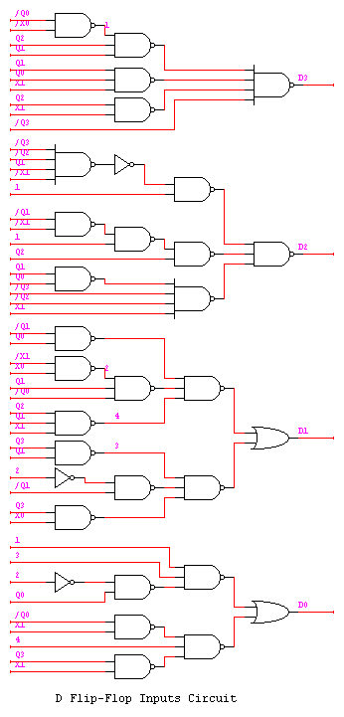
This is the circuit diagram for the D flip-flops’ inputs.

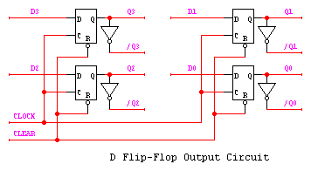
Now we connect inputs D3, D2, D1, and D0 to the D flip-flops. We also take the outputs of these D flip-flops to the inputs of circuit (because this circuit is a sequential network.)

The above two diagrams represent the counter of the circuit. Since we have the signals from the counter, we can easily derive the function for the outputs. As we assign the states in the state table, the output-signals are only activated at two states—S10 and S11, which are Q3Q2’Q1Q0’ and Q3Q2’Q1Q0 respectively.

According to the requirements of this project, we are only concerned about less, exact, and greater regarding the amount of inserted money. Hence, Q3Q2’Q1Q0’ and Q3Q2’Q1Q0 indicate exact and greater respectively. Otherwise, it indicates less. Consequently, the output signal is:

Z = Q3Q2’Q1Q0’ + Q3Q2’Q1Q0

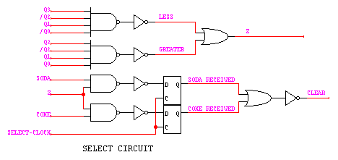
When the output signal is defined, we implement the select circuit. As a reminder, there are two products for the buyer to choose; they are coke and soda. For this select circuit, we don’t have to use truth table or K-map because we can easily figure out its circuit as illustrated figure.

Again SODA and COKE RECEIVED are kept as positive logic. In other words, the associated LED is light on right after the buyer selects the product. Consequently, the counter will be reset or clear when the buyer gets coke or soda.

Finally, we wire the whole circuit into the grate-board. The circuit is checked to make sure that there’s no unexpected error. It is also simulated in waveform; the waveform shows that this circuit works fine. In fact, the simulated waveform is not available at this time due the Logic Program disability.

CONCLUSION
This vending machine is an example of sequential network design, which applies widely in electronic circuit. The final circuit seems complicated in logic and large in size. However, it could be reduced at gate level (advanced at circuit level) so that the cost will be less.

